**Tharun Bejawada (191911509)**

**24.AUTOMATION TESTING USING SELENIUM TOOL FOR SEARCH ENGINE**

**AIM :**

To execute Automation testing using Selenium tool for opening search engine.

**PROGRAM**

package sse;

import org.openqa.selenium.By;

import org.openqa.selenium.WebDriver;

import org.openqa.selenium.chrome.ChromeDriver;

public class google {

public static void main(String[] args) {

System.out.println("hai");

System.setProperty("webdriver.chrome.driver","C:\\CSA37 Lab details\\Sellinium and junit\\selenium jar\\chromedriver_win32\\chromedriver.exe");

WebDriver driver = new ChromeDriver();

driver.get("https://www.google.com/");

// TODO Auto-generated method stub

}

}

**OUTPUT**

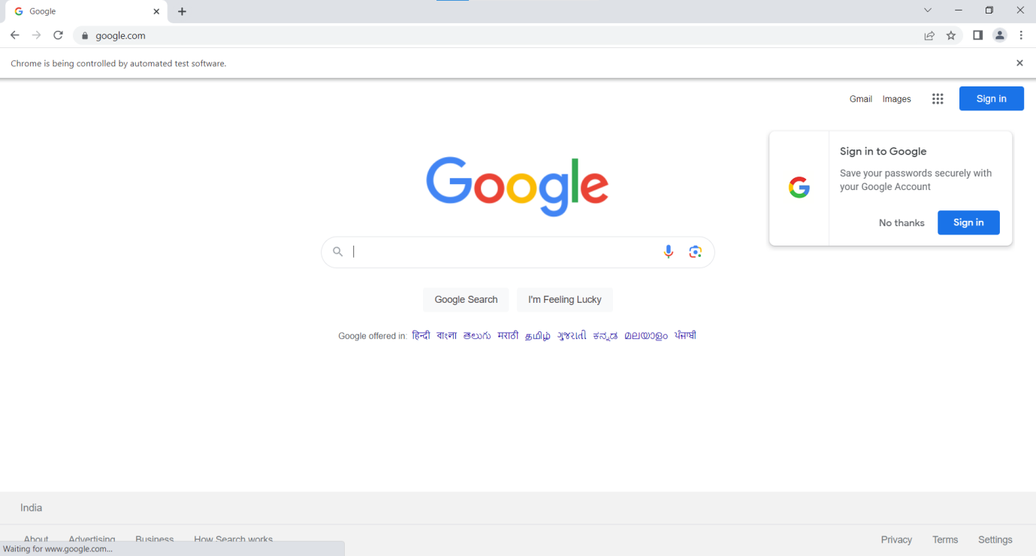

**RESULT**

Hence Automation testing for opening search engine is Executed successfully.